**A WEB-BASED COVID-19 TEST PREDICTION SYSTEM USING NEURAL NETWORK**

**BY**

**AJIBOYE Oluwaferanmi Kelechi**

**180202003**

A PROJECT SUBMITTED TO THE DEPARTMENT OF PHYSICAL AND COMPUTER SCIENCES, COLLEGE OF NATURAL AND APPLIED SCIENCES, MCPHERSON UNIVERSITY, SERIKI SOTAYO.  
 OGUN STATE, NIGERIA.

IN PARTIAL FULFILLMENT OF THE REQUIREMENT FOR THE AWARD OF BACHELOR OF SCIENCE [B.Sc.] DEGREE IN THE DEPARTMENT OF COMPUTER SCIENCE

JULY, 2022

**DECLARATION**

I hereby declare that this project was written by me and is a correct record of my own research work. It has not been presented in any previous application for any degree of this or any other University. All citations and sources of information are clearly acknowledged by means of references

__________________ __________________

AJIBOYE, Oluwaferanmi Date

# **CERTIFICATION**

This is to certify that this project was carried out by AJIBOYE Oluwaferanmi Kelechi in partial fulfillment of the requirement for the award of Bachelor of Science (B.Sc.) Degree in Computer Science, College of Natural and Applied Sciences, McPherson University, Seriki Sotayo, Ogun State, Nigeria.

__________________ __________________

Mr Abiodun Mustapha Date

__________________ __________________

Dr. F.E. Ayo Date

__________________ __________________

HOD Dr Akinola Date

# **DEDICATION**

I dedicate this work to God - the giver of every good thing, my parents for their unending sacrifice for me, and to myself because I definitely deserve some credit.

# **ACKNOWLEDGMENTS**

My profound gratitude goes to God Almighty for His Grace, Mercy, Wisdom, Knowledge, Understanding and loving kindness bestowed upon me. I greatly express my gratitude to the lecturers in the Department of Computer Science, McPherson University, and my supervisors: Dr Femi Ayo and Mr Abiodun Mustapha for their challenging and kindly advice. A special thanks to my parents Mr & Mrs Ajiboye for putting up with me, listening to my very many complaints and encouraging me to press on, to my siblings for ensuring I didn’t have to feel alone and my Uncle Niyi, Uncle Bidemi, Uncle Obi, and Uncle Iyke for their support. I greatly express my gratitude to the lecturers in the Department: Dr K. Olumurewa, Mr J. Braimoh, Dr Akinola K.E, Mr O. Oyedele, Mr D.A. Aina, and my supervisors: Dr Femi Ayo and Mr Abiodun Mustapha for their challenging and kindly advice. My appreciation also goes to‘we need fire’ – Ochei Daniel and Sayo Esther. I acknowledge my course mates who remind me every day that I’m surrounded by good people and Timothy Abigail for helping me grow with every wise word and advice. I also thank the CEO of Xclaim Labs - Mr Stephen Lawal for his patience and priceless advice in my final year. I pray that God’s Grace will continually abound for you all.

# **ABSTRACT**

The global outbreak of COVID-19 in 2019 opened up the interest for research to address diagnosis, prediction and medication for the disease. The disease grew to a widespread pandemic as a result of its ability to be transferred through contact. It has a way of affecting the respiratory, circulatory and excretory organs of the human body. Different approaches have been used to diagnose the disease but are not robust and fault tolerant to address large prediction data. In this research, a web-based prediction system was used to predict COVID-19 using neural network. The model was trained on patient results from the Israeli ministry of health and implemented using ML5. It showed a testing accuracy of 96% after training. ReactJS, NodeJS and MongoDB are used for Frontend, Backend server and database respectively. The application showed how easy and user-friendly process of carrying out the prediction process. As employed in this research, stakeholders can easily identify the likely rate at which the disease can become prevalent in an environment since the geographical location is a major factor. Hence, providing a means to plan and see how to tackle the spread.

# **TABLE OF CONTENTS**

**CERTIFICATION** iii

**DEDICATION** iv

**ACKNOWLEDGMENTS** v

**ABSTRACT** vi

**TABLE OF CONTENTS** vii

**LIST OF FIGURES** viii

**LIST OF TABLES** viii

**CHAPTER ONE** 1

1.0 INTRODUCTION 1

1.1 BACKGROUND TO THE STUDY 1

1.2 Motivation for the study 2

1.3 Problem Statement 3

1.4 Research Objectives 4

1.5 Organization of Work 4

**CHAPTER TWO** 5

2.0 LITERATURE REVIEW 5

2.5 RELATED WORKS 8

2.6 SUMMARY OF RELATED WORKS 13

**CHAPTER THREE** 18

3.0 METHODOLOGY 18

3.1 MATHEMATICAL MODEL OF A SIMPLE ARTIFICIAL NEURAL NETWORK 18

3.2 ARCHITECTURE OF THE SYSTEM 19

3.3 DESIGN CONSIDERATION 22

3.4 SYSTEM SPECIFICATIONS 22

3.5 DEVELOPMENT OF THE MODEL 22

3.6 BUILD THE FRONTEND INTERFACE 25

**CHAPTER FOUR** 27

4.0 IMPLEMENTATION 27

4.1 COVID DETECTION MODEL USING ML5 NEURAL NETWORK 27

4.2 CREATING THE FRONTEND INTERFACE 39

4.3 CREATING THE BACKEND API 45

4.4 DEPLOYING TO PRODUCTION 52

**CHAPTER FIVE** 54

5.1 CONCLUSION 54

5.2 CONTRIBUTION TO KNOWLEDGE 54

5.3 RECOMMENDATION 55

**REFERENCES** 56

# **LIST OF FIGURES**

Figure 3.1: Architecture of the System 21

Figure 3.2: Sample prototype of the User Interface 25

Figure 4.1: Dataset showing first 10 records in CSV (Comma Seperated Values) format. 27

Figure 4.2: Converting dataset from CSV to JSON using pandas 28

Figure 4.3: Sample response returned by a classification 29

Figure 4.4: Visual feedback for model training using ML5.js 33

Figure 4.5: Color palette for frontend interface 40

Figure 4.6: Test screen for user 41

Figure 4.7: Authentication screen for user 42

Figure 4.8: Homepage design 43

Figure 4.9: Folder structure for NodeJS server 48

# **LIST OF TABLES**

Table 2.1: Review of related works 17

Table 3.1: Variables required and description 23

Table 4.1: Features available in the dataset. 28

# **CHAPTER ONE**

## 1.0 INTRODUCTION

## 1.1 BACKGROUND TO THE STUDY

Artificial Intelligence (AI) is possibly the greatest innovation by man in solving many manual tasks performed by humans in various fields. John McCarthy widely regarded as the father of AI defined it as the science and engineering of making intelligent machines. AI has also been defined as intelligence exhibited by an artificial entity, (McCarthy, 1950). Such a system is generally assumed to be a computer. AI has diverse fields including (but not limited to) Automated Reasoning, Robotics, Knowledge Representation, Perception, Natural Language Processing (NLP) (Neelam, 2021).

Machine learning is an evolving field of computer algorithms with the purpose to emulate human intelligence by learning from the environment (Dong, 2020). They are considered the flagship products of the new period of so-called big data (Rong et al, 2022). Procedures based on machine learning have been applied with optimum results in multiple fields ranging from pattern recognition, computer vision, spacecraft engineering, finance, entertainment, and computational biology to biomedical and medical applications (Cichoki et al, 2021). More than 50 percent of the patients diagnosed with cancer receive ionizing radiation (radiotherapy) as a major aspect of their treatment, and it is the main recovery modality at advanced stages of disease. (Issam et al, 2015)

A machine learning algorithm can be defined as a computational procedure that makes use of input data to perform a specific action or complete a given task without being explicitly programmed to exact a particular outcome (Wigmore, 2021). These algorithms traditionally learn from actual historic data that can include text, pictures, tables e.g. CSV files, and even voice and video data. (Quiroz-Jua´rez et al, 2021)

Coronaviruses are enveloped, non-negative single-stranded huge RNA viruses that contaminate human beings, but can also infect a wide spectrum of animals (Maier, 2015). Coronaviruses were first documented in 1966 by the scientists: Tyrell and Bynoe, who extracted and maintained the viruses from common-cold infected patients. Based on their morphology as spherical virions with a core shell and surface projections that were similar to a solar corona, they were dubbed coronaviruses. (Velavan & Meyer, 2020). In December 2019, a huge number of pneumonia cases were reported in the Wuhan province of China. Many of these cases reported visiting seafood and live animal markets. Investigations found that the disease was caused by a new strain of the coronaviruses. The disease was subsequently named COVID-19. This virus later spread to China and other parts of the world (Fauci, 2020).

Coronaviruses are large groups of viruses and they consist of a core of genetic material enveloped by a liquid covered in protein spikes. This gives them an appearance of a crown. Crown in Latin is ‘Corona’. Hence the name, coronavirus (Chorba, 2020). These viruses can cause respiratory disorders ranging from the common cold to more severe viruses including SARS (first discovered in China in 2003), MERS (First discovered in Saudi Arabia in 2012) and SARS-COV2 (discovered in China in 2019) (Liu et al, 2020). Coronaviruses circulate in a range of animals including Camels, Bats and Snakes, the virus could however spillover to humans due to a range of factors including contact between humans and animals (Rathore & Ghosh, 2020). The disease spreads between humans when an infected person comes in contact with an uninfected person. It can also spread through droplets (Awais et al, 2020).

COVID has different symptoms at different stages in the human body. The incubation stage of the virus (ranging from 5-6 days) include symptoms such as fever, fatigue, cough, and loss of smell or taste, sore throat (Iannarella et al, 2020). There can also be more severe symptoms like pneumonia. However some people may remain asymptomatic (show no symptoms of infection) (Petrosillo, 2020).

The most popular COVID test is Reverse Transcriptase-Polymerase Chain Reaction (PCR), this test identifies the virus via its genetic fingerprint (Cheng, 2020). Treatment for COVID is majorly based on supportive care. There is currently no cure for the virus. The preventive measures for the virus include Covering the mouth and nose while sneezing, washing hands regularly with soap and water, maintaining social distance and appropriate use of masks and hand gloves (Therbauld, 2021). Contacting a medical personnel as soon as you experience symptoms guarantees the greatest chance of recovery from the virus (WHO, 2020)

## 1.2 Motivation for the study

The following are the motivations for the study:

1. The study will aid the enactment of lockdown and isolation rules. It will also reduce the impact of the virus in regional localities by determining the lockdown rules - if applicable - to be enacted.
2. It will enable organizations to efficiently operate even with infected members of staff. Remote working has enabled many organizations to continue functioning with slight difficulty during the pandemic period (Sivasubramanian, 2020)
3. It will give a better understanding of the spread of the coronavirus. The knowledge of the pandemic is insubstantial. A better understanding of the nature of the virus and how it spreads from patient to patient will aid health workers in minimizing the transmission (Gulati, 2020).
4. Patients who are currently in the incubation phase of the virus can receive immediate care for enhanced chances of recovery (WHO, 2021)

## 1.3 Problem Statement

A number of techniques have been put in place by respective governments, world organizations and private companies to counter the spread of the virus, however as humanity still has a lot to learn from COVID-19, many of these techniques are flawed. The problems facing the world today are:

1. According to the World Health Organization, there is no cure for the disease (McAleer, 2020).
2. High cost of manufacturing, distributing of testing kits, vaccines and preventive measures like hand sanitizers, face-masks etc. (Zunyou et al, 2020).
3. The risk of infection and transmission of the disease is higher when individuals go to testing centers. The risk of uninfected patients contacting the disease is increased when they visit testing centers. The risk of spread on infected people to others is also increased when they journey out to get tested. An alternative to this is home/office delivered testing kits, but this is one of the most expensive means of getting tested (Garner, 2021).

## 1.4 Research Objectives

The following are the research objectives of this study:

1. Perform a critical analysis on existing systems for detecting the coronavirus in patients using only symptoms
2. Design a system for predicting coronavirus test results and validate system performance and reliance

## 1.5 Organization of Work

The remainder of the work is so: Chapter two focuses on the introduction to coronaviruses, COVID-19, Artificial Intelligence & Machine Learning, Neural Networks and related existing works.

Chapter three focuses on the methodology used in implementing the system, architectural components of the system and algorithms. Chapter four describes the actual implementation of the system, result analysis, evaluation of the system and summary. In the Chapter five, conclusions are made from the implementation of the system with contributions to knowledge and recommendations of the research methodology.

# **CHAPTER TWO**

## 2.0 LITERATURE REVIEW

**2.1 Overview of Coronaviruses**

As stated in the previous chapter, Coronaviruses are enveloped, non-negative single-stranded huge RNA viruses. Towards the end of the year 2019, In December a rapid outbreak of an unidentified disease termed ‘Pneumonia of Unknown cause’ originated in the Wuhan Hubei Province of China (Fauci, 2020). The outbreak spread substantially to infect more than 9,000 people in china with more than 200 deaths and spread to infect 106 people in 19 other countries up until January 2020 (Singhal, 2020). Sometime later, the source of this mysterious disease was traced as a novel strain of the coronavirus by various independent laboratories all over the world (He et al, 2020). This virus has since become known as Severe Acute Respiratory Syndrome (SARS COV-2) and the disease generated by the virus names Coronavirus disease 2019 (COVID-19) (He et al, 2022)

To get a better understanding of COVID-19 causing this pandemic, we must go back to the origin of these viruses. The coronaviruses are a family of viruses commonly found in avian and mammalian species (Perlman, 2020). They are similar to each other in morphology and chemical structure, for example, the genetic structure of coronaviruses in humans and cattle have no resemblance (Ziebuhr, 2005). There is no proof that human coronaviruses could be borne and transferred by animals. In animals, several coronaviruses can penetrate several variety of tissues and lead to a variety of illnesses, but in human beings, there is only evidence that they can lead to upper respiratory diseases and sicknesses, i.e. common colds (Van Der Hoek et al, 2004). On uncommon occasions, gastrointestinal coronavirus infection has been linked with diarrhea outbreaks in children (Zu et al, 2020). Coronavirus virions are spherical to pleomorphic enveloped particles. This envelope is reinforced using projecting glycoproteins, and cover a central core consisting of protein encapsulated within which is just one strand of positive-sense RNA (Mr 6 × 106) connected with nucleoprotein (Harari, 2020). The encircled glycoproteins are in charge of the attachment to the host cell and also enforce the main antigenic epitopes, most especially the epitopes detected by neutralizing antibodies. OC43 also possesses a Hemagglutinin (Tyrell & Myint, 1996).

Although, the source of the COVID-19 pandemic is zoonotic in nature, the available epidemiologic data depicts that human transmission is obviously occurring (Harapan et al, 2020). It is proven to spread through respiratory fluids from coughing and sneezing of an infected person or persons to uninfected people who come in close reach to them (Dhama et Khan, 2020). The distance for this close contact is said to be about 6 feet. Transmission can also occur to someone who comes in close contact with infected surfaces or objects and then make contact with their eyes, ears, nose or mouth (Jiang et al, 2020). The virus spreads most from symptomatic patients who are at the peak of their symptoms (Zhou & Zhang, 2020). However, research is also ongoing to prove if the virus can be spread from people who are infected but have not yet become symptomatic (showing symptoms). These group of patients are said to be asymptomatic (Holstein, 2020).

The most dominant symptoms of the COVID-19 are fever, dry cough, shortness of breath. 10% of patients have presented Nausea and diarrhea 1-2 days before to the growth of fever in a study conducted in an unnamed hospital in Wuhan, China. 75% of the patients in this same study reported a condition known as bilateral pneumonia (Chang et al, 2020). Bilateral Pneumonia is a serious infection of pneumonia that can inflame a patient’s lungs. The disease affects the tissue around the small air sacs in the lungs (Bathoorn et al, 2009)

**2.3 Introduction to Artificial Intelligence**

Popular commercial applications of Artificial Intelligence include Language Processing, Machine Learning, and Pattern Recognition etc. (MahaLakshmi, 2021).

Products like Siri, Alexa are classified as Language Processing software capable of understanding human language including slangs, accents and filtering out background noise. These software can also be used for voice authentication to prevent unauthorized access (Brownlee, 2019).

Artificial Intelligence is also used to regulate temperature in smart cars and smart homes. AI is also employed in IoT devices & software (Internet of Things). IoT deals with smart devices able to communicate with each other and human beings without requiring direct input from humans. Smart devices like Refrigerators, Waste bins and Air Conditioners can take action based on certain conditions without receiving instruction from their users. (McClelland, 2021)

Beyond these applications, AI can also be used in the medical industry. The major application in the field of medicine has been the use of Machine Learning through Neural Networks (Ozsahin, 2020).

**2.4 Concept of Neural Networks**

A Neural Network is a series of algorithms that endeavors to recognize underlying relationships in a set of data through a process that mimics the way the human brain operates (Chen, 2021)

A weight is a parameter within a neural network that transforms input data within the network’s hidden layers (Rahaman et al, 2019)

Bias in neural networks can be seen as analogous to the role of a constant in a linear function, where the line is effectively transposed by the constant value (Pavelka & Proch´azka, 2005)

With artificial intelligence, the neural network is trained by varying the weights and the bias. In simpler terms, the inputs are varied to reduce as much as possible the loss function. This is similar to linear regression

## 2.5 RELATED WORKS

This section entails a review of related works in the diagnosis of diseases with the aid of Artificial Intelligence, detection of COVID-19 using symptoms and other approaches

**2.5.1**

**An expert system to diagnose COVID-19 and predict its severity using chest CT scans**

**(Abbasi et al, 2021)**

* **Objectives**

1. To provide an inexpensive and concise diagnostic test for majorly asymptomatic patients
2. Design a system to detect the severity of the virus in the patient

* **Methodology used**

The authors used a Deep Learning model where they automatically learned an efficient component representation of an image. This model has been successfully utilized in classification of various images and investigative tasks. Using transfer learning for feature extraction from the available Computerized Tomography (CT) images in their data sets was performed using various easily available Convolutional Neural Network (CNN) already trained models from ImageNet. The novelty of their suggested methodology is that it makes use of a mixture of already trained CNN based models to bring out features and shallow learning procedures such as Support Vector Machine (SVMs) for the means of classification. The proposed methodology is someway based on the pattern of transfer learning. Their aim was to acquire knowledge on two different functions for the identification and severity estimation of COVID-19. To accomplish this task, they made use of three separate machine learning-based classification procedures: classical Support Vector Machine (SVM), Random Forest (RF), and Gradient Boosting Machine (XGBoost)

* + **Results**

1. Improved performance over already existing methods including methods proposed by Kang et al, where models were trained using handmade features and produced an accuracy of 86%
2. Proposed methodology can not only be used for the diagnosis of COVID-19 but also be used to predict the severity of the virus in patients and reduce the surge of the virus by advising timely isolation.
   * **Strengths**
3. The proposed system is made easily available to the public through an open-cloud based webserver and open source code
4. The system detects not just the presence of COVID in a person but also determines the severity to determine counter measures
   * **Weaknesses**
5. The proposed methodology using CT scans causes certain problems like inability of very symptomatic patients to hold breath
6. CT scans can also lead to bone damage around the scanned area, this limits the number of scans the average human can run

**2.5.2**

**Artificial Intelligence-enabled rapid diagnosis of patients with COVID-19**

**(Mei et al, 2021)**

* + **Objectives**

1. To provide an alternate medium to testing COVID than the standard PCR test which takes up to 48 hours to complete
2. To control the spread of the virus by implementing a system that can track potential spread of the virus
   * **Methodology used**

The authors accumulated data on initial test CT studies and other hospital-related information from 905 patients from the period of 17th of January till 3rd of March 2020 in centers in thirteen provinces in China where the ill subjects had been exposed to the virus, fever and a PCR test. The clinical information recorded included: Age, Gender, Exposure history, symptoms, white blood cell count, percentage lymphocytes etc. The categorical parameters were Sex, Exposure history and Symptoms. They made use of LabelEncoder function in the popular scikit-learn package to encrypt the defined categorical parameters into numeric parameters. Then they normalized all the features from 0 to 1 with the MinMaxScaler function in the scikit-learn module for future development of the model. The available data from PCR tests were used to train the AI models. These models were developed using CT images and other clinical data. Then they created a joint CNN model which was a combination of radiological and clinical data. The first step after the models was to pre-process the images. They selected relevant images from the many images produced by a CT scan. Image Segmentation was used to detect parenchymal tissue from this images. CT images were then segmented into two parts, body and lung. They body part was divided by obtaining the biggest attached component that had both pixels and an intensity greater than 175. The size of the lung region was increased by 10px to fully show the pleural boundary. Images were abandoned if the size of the lung was less than 20% of the body area. Two CNNs were used: Slice selection CNN and Disease diagnosis CNN. The researchers used as the primary function a binary cross-entropy. The neural network was trained using the Adam optimizer and had a learning rate 0.001. They designed an impotently supervised task to give starting weights of the CNN model.

The joint model was created by combining CT imaging and other clinical data. The authors trained a model to integrate both data from the CT and clinic. They applied the general averaging level to the final layers of the convolutional network earlier prescribed to extract a 512 measured feature vector to depict a CT output. The sum of these measurements was used as the overall objective function to train the joint model. They used an optimization strategy of model 1 to train the CNN. It was also initialized by the weakly supervised task of classifying the tiny image patches

* + **Results**

1. Comparison of the ROC curves for the joint model, the CNN model trained on the foundation of CT images, the Multilayer Perceptor model trained using clinical data and two radiologists
2. Comparison of accomplishments of diagnosing patients who are ill with the virus with normal CT scans yielded 13/25 for the CNN model, 16/25 for the MLP model and 16/25 for the Joint model.
   * **Strengths**
3. CNN models, MLP model and the Joint model are trained on datasets from wide range of sources in the Wuhan Province of China. This gives diversification of data and enhances the probability of AI generating valid test results for patients
4. Test analysis for result prediction is 68% valid and this rapidly reduced the time taken averagely to detect COVID patients without AI
   * **Weaknesses**
5. Two radiologists were required to train the basis of the MLP model unlike the other CNN model.
6. Detection of COVID in patients by the CNN model yielded only a 52% probability of success as from 25 patients, only 13 were detected

**2.5.3**

**Application of Big Data Analytics to Control COVID-19 Pandemic**

**(Alsunaidi et al, 2021)**

* + **Objectives**

1. To reduce the spread of the coronavirus throughout the world by application of Big Data Analytics techniques
2. To diagnose the virus in patients by detecting the virus in pre-symptomatic patients before they become contagious
3. Reduce the strain on medical practitioners by applying Big Data Analytics
   * **Methodology used**

The authors proposed a model that will differ COVID from other chest diseases. This model makes use of many different sensors placed on the body to gather information and keep track of the patient’s health status involving temperature, blood pressure, heartbeat, respiration, glucose level etc. The information gathered was kept on a cloud database with Expert Systems that aid diagnosis of ill patients using their symptoms and determine the appropriate response for patients suspected of having the virus.

The authors gleaned multiple papers about mathematical models to enhance the effectiveness in the process of detecting and estimating COVID positive patients.  
The authors also obtained medical data which they believe the analysis can predict future circumstances, give a better understanding of the current situation and improve decision making process. This data was obtained from many public open databases on the internet. The authors discovered various tools that can be used to analyze data obtained from prior research including the R language, Python, MATLAB, MS Excel, and GraphPad Prism among many others.

* + Results

1. They provided a taxonomy structure which grouped the possible applications of COVID-19 into four spheres: diagnosis, estimate or predict risk score, healthcare decision-making, and pharmaceutical.
2. The authors also assessed essential insights on a variety of difficulties that may hamper the application of data analytics assets for COVID-19. These disadvantages include healthcare information security and patient confidentiality matters, the arduousness of distributing data among professionals, lack of data credibility for some researches that may give rise to flawed results, and the patients’ collaboration in distributing certain aspects of their clinical data
   * **Strengths**
3. Due to the increase in the volume of data over time as the pandemic continues to effect various countries over the world, the credibility of the author’s work will continue to scale globally leading to a rise in the accuracy.
4. A number of possible actions to take in the future can be assessed from the authors research
   * **Weaknesses**
   1. Absence of data validation for certain aspects
   2. Confidentiality within patients with the virus lead to limited clinical data available depending on the category. The difficulties involved in sharing data with other researchers to enhance their work.

## 2.6 SUMMARY OF RELATED WORKS

|  |  |  |  |  |  |
| --- | --- | --- | --- | --- | --- |
| **Title** | **Objectives** | **Methodology** | **Results** | **Strengths** | **Limitations** |
| Application of Big Data Analytics to Control COVID-19 Pandemic  (Mei et al, 2021) | To reduce the spread of the coronavirus throughout the world by application of Big Data Analytics techniques | Placed sensors on certain areas of patient’s body to gather information including: temperature, blood pressure etc.  Made use of tools like MATLAB, MS Excel, Python & R to analyze the information acquired | They provided a taxonomy structure which grouped the possible applications of COVID-19 into four spheres: diagnosis, estimate or predict risk score, healthcare decision-making, and pharmaceutical. | Due to the increase in the volume of data over time as the pandemic continues to effect various countries over the world, the credibility of the author’s work will continue to scale globally leading to a rise in the accuracy. | Confidentiality within patients with the virus lead to limited clinical data available depending on the category. The difficulties involved in sharing data with other researchers to enhance their work. |
| Artificial Intelligence-enabled rapid diagnosis of patients with COVID-19 (Alsunaidi et al, 2021) | To provide an alternate medium to testing COVID than the standard PCR test which takes up to 48 hours to complete | Use of Chest CT Scan data and other clinical information from a survey to detect COVID-19 | Comparison of accomplishments of diagnosing patients who are ill with the virus with normal CT scans yielded 13/25 for the CNN model, 16/25 for the MLP model and 16/25 for the Joint model | Test analysis for result prediction is 68% valid and this rapidly reduced the time taken averagely to detect COVID patients without AI | Detection of COVID in patients by the CNN model yielded only a 52% probability of success as from 25 patients, only 13 were detected |
| An expert system to diagnose COVID-19 and predict its severity using chest CT scans  (Abbasi et al, 2021) | To provide an inexpensive and concise diagnostic test for majorly asymptomatic patients.  To Design a system that can detect the severity of the virus in the patient | Created a model based on Deep Learning Techniques and three separate machine learning-based classification procedures: classical Support Vector Machine (SVM), Random Forest (RF), and Gradient Boosting Machine (XGBoost) | Improved performance over already existing methods including methods proposed by Kang et al, where models were trained using handmade features and produced an accuracy of 86% | The proposed system is made easily available to the public through an open-cloud based webserver and open source code. The system detects not just the presence of COVID in a person but also determines the severity to determine counter measures | The proposed methodology using CT scans causes certain problems like inability of very symptomatic patients to hold breath  CT scans can also lead to bone damage around the scanned area, this limits the number of scans the average human can run |
| A model for the effective COVID-19 identification in uncertainty environment using primary symptoms and CT scans (Abdel-Basst et al, 2020) | To Create a diagnosis model for COVID-19 assumption and diagnosis of medical signs to describe proper care methods | The authors made use of the BWM (Best Worst Method) to assess a group of surrogate options with consideration to a group of decision parameters. The BWM is based off a systematic pairwise comparison of the decision criteria | The model can differentiate COVID-19 from four other viral chest diseases with 98% accuracy | Model requires primary symptoms for its training | Method of application and consensus findings are applicable to a certain geographic region, leading to possible inaccuracy of the model in other locations |
| A Headset Like Wearable Device to Track COVID-19 Symptoms. (Stojanovic et al, 2020) | To design and develop a wearable device capable of tracking key symptoms of the virus | The authors used symptoms (both primary and latter symptoms) of the virus. These symptoms were recorded using sensors placed on the patient’s body. The information was used to train a model for prediction | The methodology gave ground to good and reliable outputs and can be enhanced to absorb the use of more sensors to diagnose other COVID-19 symptoms. | The paper presents a low cost and flexible design of a medical device for purposes of detecting and tracking symptoms of COVID_19. Requires only a simple configuration | The model requires extensive patient input to obtain data which the authors used for model training |
| COVID-19 symptoms predictive of healthcare workers' SARS-CoV-2 PCR results (Lan et al, 2020) | To provide a symptom-based screening approach among health workers that will prove crucial in eliminating the spread of the virus. | The authors performed a retrospective study of HCWs undergoing both COVID-19 telephonic symptom screening and nasopharyngeal SARS-CoV-2 assays during the period, March 9—April 15, 2020 | Some of the strongest symptoms of COVID discovered in their research included: Fever, anosmia, and myalgia while no symptoms were only peculiar to nasal congestion/sore throat associated with negative cases | Screening of patients was conducted with phones over the internet, this ensured that patients could isolate while performing necessary tests | Accuracy of prediction compared to other researches which made use of CT scans or bodily sensors was much lower than using phone-based symptoms tests |
| Exploring Automatic Diagnosis of COVID-19 from Crowdsourced Respiratory Sound Data  (Brown et al, 2020) | To use digital analysis to gather respitatory data to assist early diagnosis of COVID-19 | The authors gathered data from users via web apps and mobile apps and used convolutional neural networks (CNNs) to detect cough within ambient audio, and diagnose three potential illnesses (bronchitis, bronchiolitis and pertussis) based on their unique audio characteristics | The authors presented an ongoing effort to crowdsource respiratory sounds and study how such data may aid COVID-19 diagnosis | The mobile app built reminds users to provide samples every couple of days: as a consequence the authors have a number of users for whom they could study the progression of respiratory sounds in the context of the disease. This is very relevant for COVID-19. | The authors have no ground truth regarding health status, and so took users from countries where COVID-19 was not prevalent at the time as likely to be truly healthy when self-reporting as such. shown a limited investigation of the difference between cough sounds in COVID-19 and asthma |
| Identification of high-risk COVID-19 patients using machine learning (Quiroz-Jua´rez et al, 2021) | To create a neural network that predict whether a given patient | Created machine learning algorithms that were trained using data obtained from the Mexican Government | Their technology enables rapid identification of high-risk patients. The authors also showed that the training of their neural networks can accomplish the highly non-trivial task of determining an optimal estimator to be used as part of the standard hypothesis testing method | The Accuracy, specificity, and sensitivity of their neural network reaches values up to 93.5%, 90.9%, and 96.1%, respectively | Estimators can only apply in an advanced clinical stages where the patients are already in need of specialized care |

Table 2.1: Review of related works

# **CHAPTER THREE**

## 3.0 METHODOLOGY

## 3.1 MATHEMATICAL MODEL OF A SIMPLE ARTIFICIAL NEURAL NETWORK

A simple neural network consists of *n* number of inputs, only one neuron and one output, where *n* is the number of features available in the dataset. A feature in a dataset can simply be defined as a input variable or a column in the dataset. The features for our neural network are discussed in table 3.1. The process of passing the data through the neural network is termed: *Forward Propagation* and the forward propagation carried out will be explained below:

1. For every input, multiply the input value *Xi* with weights *Wi* and add all the values. Weights – represent the strength of the connection between neurons and determine how much influence the given input will have on the neuron’s output. If the weight *W1* has a greater values than *W2*, then the input *X1* will have a greater influence on the output than *W2*.

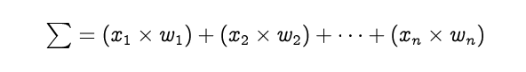

The row vectors of the inputs and weights are x = [x₁, x₂, … , xₙ] and w =[w₁, w₂, … , wₙ] respectively and their dot product is given by

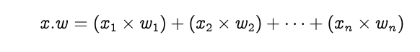

Therefore, the summation is equal to the dot product of the vectors *x* and *w*

ann3

1. A bias *b* is added to the summation of multiplied figures and is termed *z*. Bias (also called the offset) is necessary in most of the cases, to move the entire activation function to the left or right to generate the desired output values

ann4

1. The value of *z* is passed to a non-linear activation function. Activation functions are used to bring a concept of non-linearity into the output of the neurons, without which the neural network will be simply a linear function. Moreover, they have a massive impact on the learning speed of the network. We shall use a popular function known as logistic function

as out activation function

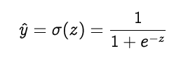

In the above equation, the output of the neural network after the forward propagation is known as the predicted value *y*

## 3.2 ARCHITECTURE OF THE SYSTEM

The following components & tools will be required for the system:

1. Datasets from the Israeli Ministry of Health containing data that will help identify whether a person is positive with the virus or not based on some predefined standard symptoms set by the WHO.
2. ML5.JS: ML5 is a free to use machine learning package that was built on Tensorflow. ML5 runs in the browser on the frontend and can be used for Neural Networks for classification or regression tasks
3. Python library: Since Python is the primary programming language for data science activities, it will be used to process the dataset obtained. Python contains several libraries that allow developers to work with large sets of data. Pandas is the most popular library for handling data. Pandas will be used to work with the data obtained, convert it to a JSON (Javascript Object Notation) format before it will be used in ML5
4. JavaScript: The development of both the Frontend and Backend of the application will be done using JavaScript frameworks: React and NodeJS. React will be used to write JSX that will compile down to the standard HTML, CSS and Vanilla JS for frontend UI development. NodeJS which is simply JavaScript on a server (backend) will handle the API creation and will become the server which we will make requests to from the frontend
5. MongoDB: MongoDB is the most popular database for NodeJS applications. Unlike SQL, MongoDB does not store data in tables and rows and columns. Instead, data is stored in JSON format which is a better structure for data that may contain undefined values. MongoDB provides a free hosting tier which will be used in the initial stages of the applications
6. Github: All frontend and backend code will be stored on Github. The workflows for CI/CID (Continuous Integration/Continuous Deployment) will be instantiated from Github when we integrate with Azure Static hosting
7. Microsoft Visual Studio Code: VS Code is an Integrated Development Environment that will be used to write locally sourced code during the staging phase.

Figure 3.1 describes what the typical architecture is. The datasets contains cleaned data on patients who recorded their symptoms Using the Python library in Jupyter Notebooks, Pandas, a Notebook will be created so we can convert out dataset files from CSV to JSON. We can then proceed with creating and training the model with ML5 on the browser. When the model has been built, NodeJS will be used to handle API calls as seen in Figure 3.1. All API requests handled by NodeJS will enable the storage of data in the popular database MongoDB. When API requests are made by the Node server, responses can be sent to the React frontend which will serve as the User Interface on the Client Side.

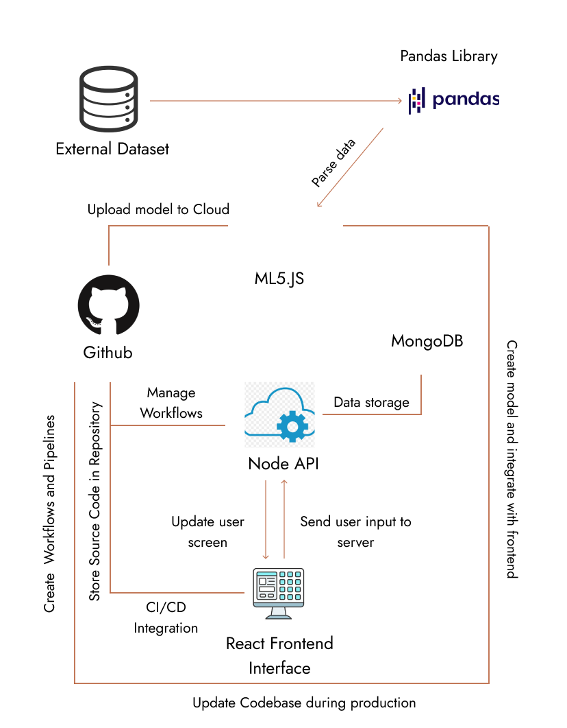

Figure 3.1: Architecture of the System

## 3.3 DESIGN CONSIDERATION

Due to high processor requirement in creating neural network models, a computer system with the following specifications will be used to train and test the model during development:

* 16GB DDR4 RAM
* Intel Core-i7 9700K
* Nvidia GTX 1660ti

A mobile or desktop device with a web browser will be required to use the developed application

## 3.4 SYSTEM SPECIFICATIONS

The system will be required to perform the following:

1. Determine the probability that a user is positive with COVID-19: This will be done by collecting data from the user including: Symptoms, Medical history, possibility that user has come in contact with an ill patient, geographic location, number of ill patients in geographic location, pandemic severity in region, age group.
2. Update model with new data and re-train: Use user data to retrain the model to predict more accurate results.

## 3.5 DEVELOPMENT OF THE MODEL

The following steps will be taken in developing the prediction model

1. Data Collection: This is the first process in developing the model. The primary dataset used in the training of this Model was obtained from a publicly available dataset by the Ministry of Health in Israel. The data contains the records of more than 1 million patients who were tested for COVID-19. Many of the patients were symptomatic. While some of the patients, after testing were found to not havve the virus, their records were kept thus increasing the accuracy of the data for data scientists. The symptoms on which this data was based can be found on the official WHO website. The data consists of the cough, Age, Current Symptoms, gender, and result outcome.
2. Preparation of Data/ Data Wrangling: The data format which is going to be used in creating the ML5 neural network is JSON (Javascript Object Notation) format. It will be converted from CSV (Comma Separated Values) to JSON first. The only required field for the training is the “data” which will be imported into the neural network.
3. Choose the Model: Since the model will use Neural Network algorithm, the appropriate one will be selected, then the desired task which is classification will also be defined
4. Train the Model: The model will be using the dataset obtained. It will recognize and deduce if a user could be positive with the virus using the variables listed in Table 3.1
5. Evaluation of the model & Tune Parameters
6. Prediction and Inference

The following inputs are required for the model to predict test results. Table 3.1 displays a list of inputs from the user required by the model. This inputs will be fed into the algorithm.

|  |  |
| --- | --- |
| **VARIABLES** | **DESCRIPTION** |
| Gender | User gender: Male or female |
| Location | Geographic location |
| Symptoms | Does user have COVID-19 related symptoms |
| Age | Users age in years |

Table 3.1: Variables required and description

Based on the received input for some of the variables, further inputs could be collected from the user including: Severity of symptoms experienced and current medical condition

Algorithm for Diagnostic Process

1. RECEIVE USER INPUTS AS LISTED ABOVE
2. TRANSMIT USER DATA INTO MODEL
3. PROCESS INPUTS & DIAGNOSE TEST RESULTS
4. RETURN MODEL OUTPUT RESULTS
5. RECOMMEND POSSIBLE COUNTER MEASURES DEPENDING ON RESULTS

MAJOR FACTORS AFFECTING A POSITIVE TEST

1. If the user is in a vicinity with a high spread of the virus
2. If the user has a high scale of difficulty in breathing
3. User has shortage of breath after doing minor or no strenuous activities
4. Experiences unusual respiratory pains in regions around the chest and back
5. Has recently travelled to a region that is highly affected by the spread of the virus
6. Vaccination status of the user: If the user has been vaccinated this reduces the possibility of being positive with the virus. However if the user has not been vaccinated, the chances of getting the virus are increased

MINOR FACTORS AFFECTING A POSITIVE TEST

1. If the user has frequent sneezing without cough or respiratory pains
2. If the number of occupants in the sleeping area is high (poor isolation guidelines)
3. If the user came across a positive patient but has no symptoms (This is not a perfect ideology since many patients – particularly those infected with the Omicron variant – are asymptomatic)
4. If the user has a medical history of respiratory related diseases and has symptoms related to both his medical conditions and COVID-19. This may affect the result and the user will be advised to take an actual PCR test in a qualified medical center

PRE-EXISTING MEDICAL CONDITIONS

Medical conditions like Diabetes, Asthma and heat conditions including cardiac diseases and high blood pressure can also affect the symptoms and severity of symptoms displayed. People with pre-existing medical conditions will often experience more severe symptoms than regular patients. If a user with a pre-existing medical condition listed above was to undergo a test, the user would most likely experience extreme symptoms if positive with the virus (Sullivan, 2022)

If a user who has poor isolation at work or home generates a positive result prediction, then other members would be advised to take a test as well. Since the tests are not performed taking actual fluid from the users, a more accurate diagnostic would require the user taking at least three tests and finding the average result based on the tests

## 3.6 BUILD THE FRONTEND INTERFACE

The frontend development process is divided 4 into major modules:

1. The UI/UX design
2. The Implementation of the Design
3. Mobile-responsive view
4. Testing the developed frontend

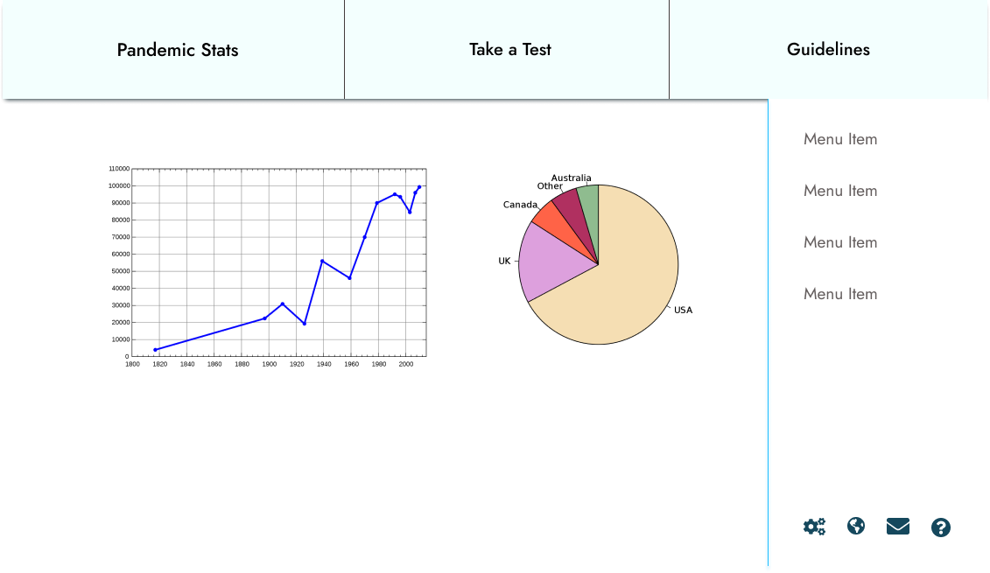

Figure 3.2: Sample prototype of the User Interface

The UI/UX design is typically performed after requirement gathering and analyzing. The requirement gathering stage is complete upon development of the model, so we proceed to the design of the interface. In this case, we will use Figma although there are numerous alternatives available including Illustrator, Framer etc.

Next, we will implement the design in the popular frontend framework ReactJS. As is seen in the Architecture Diagram in Figure 3.1, React will serve as the interface the users will interact with.

After the React implementation with the aid of certain modules including: MUI and js-ccokie, we will design a mobile-first version of the frontend. As at November 2021, more than 46 percent of the total activities done on the web are done with mobile devices, compared to approximately 50.4 percent coming from desktops and PCs (Oberlo, 2021)

The final stage of the frontend development is the Evaluation and Testing. Testing will ensure that there are no glitches or bugs hidden in the interface and we need to the design to ensure that the constraints from the UI are applicable in the code. The frontend of the application should be complete.

# **CHAPTER FOUR**

## 4.0 IMPLEMENTATION

## 4.1 COVID DETECTION MODEL USING ML5 NEURAL NETWORK

**4.1.1 TRAINING THE NEURAL NETWORK MODEL**

An Artificial Neural Network (ANN) is based on a collection of connected units or nodes called artificial neurons which loosely model the neurons in a biological brain.

An ANN consists of neurons. A neuron in an ANN is simply a building block similar to the ones in the human brain. Neurons make up the hidden layers in an ANN that process input layers to produce output. There is a concept of activation functions in neurons. These activation functions take inputs and give outputs. When a neuron receives a value, it passes the value through the activation function.

An artificial neural network (ANN) solves challenges in domains like pattern recognition and game play by combining biological principles with modern statistics. The basic paradigm of neuron analogues coupled in a variety of ways is adopted by ANNs Andreas (2003).

Below are the first 10 records of the dataset in csv format:

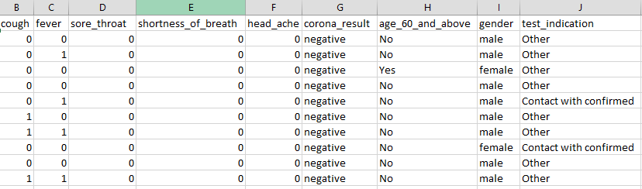

Figure 4.1: Dataset showing first 10 records in CSV (Comma Seperated Values) format.

To make use of the dataset in ML5, it will be easier to make use of it in .JSON format. JSON (Javascript Object Notation) is a popular form of exchanging and storing data particularly on web based applications. To convert the dataset from CSV to JSON, pandas library from python and Jupyter Notebooks will be used:

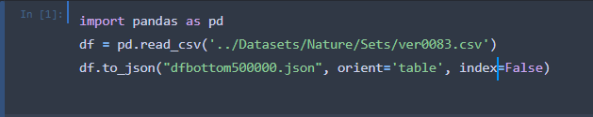

Figure 4.2: Converting dataset from CSV to JSON using pandas

A new Jupyter terminal is created and then the pandas library is imported. The dataset is opened in a pandas dataframe and then .to_json() method is called to convert the CSV dataframe to JSON format.

Now that the dataset is in JSON format, the process for training the model with the JSON file can commence

The features for the Neural Network from the records in the dataset are as follows:

|  |  |  |
| --- | --- | --- |
| INPUT | VALUE | REMARK |
| Cough | 1 or 0 | Does user have cough: true or false |
| Fever | 1 or 0 | Does the user have a fever: true or false |
| Sore_Throat | 1 or 0 | Does the user have a sore throat: true or false |
| Head_Ache | 1 or 0 | Does the user have a head ache: true or false |
| Shortness_of_Breath | 1 or 0 | Does the user experience difficulty in breathing: true or false |
| Gender | 1 or 0 | What is the user’s gender: Male or Female |
| age_60_and_above | 1 or 0 | Is the user above the age of 60 or not |

Table 4.1: Features available in the dataset

The gender input accepts either “Male” or “Female” and transforms it into binary inputs: 0 or 1. If user is male, gender = 0, else if user is female, gender = 1.

All inputs have to be converted to numerical values between -1 to 1. So values can range between -1, 0 and 1. 0 represents false, 1 represents true and -1 can be “mid” or “other”.

The model generates a single array of possible output for each classification: “negative”, “positive”, and “other”. The array contains objects for each possible output listed above. The objects will also contain a “confidence” value. The total of all confidence values will equal to 1. This means that the output with the highest classification will be the classification decision.

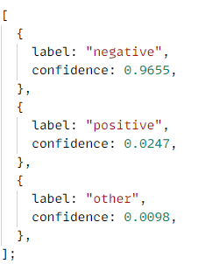

Figure 4.3: Sample response returned by a classification

Consider figure 4.3 e containing a sample response returned by running a classification on a set of user inputs. The response is an array of three objects. Each object contains a ‘label’ and a ‘confidence’ property. The label is of type string while the confidence is a float variable. The confidence values all add up to 1 showing that the result is accurate. The output object with the highest confidence value is the model’s prediction of the most likely outcome of the test result.

ML5 Neural networks can perform either Classification and Regression tasks. We shall be creating a classification model. The model predicts a value for each classification after training on values of other data in the dataset. This model will make use of Classification to predict either positive or negative result for each test run. According to ML5, these are the following steps to create and train a model to perform classifications:

Step 1: Load data from your dataset or create some raw data in realtime

Step 2: Set your Neural Network options

Step 3: Initialize the neural network

Step 4: Add data to the Neural Network

Step 5: Normalize your data

Step 6: Train your neural network

Step 7: Use the trained model to make a classification

Step 8: Obtain results on your classification

Using the above steps, the model will be implemented in code:

1. Step 1: Load Data

The first step is to import the dataset to be used. We will fetch the dataset using Axios library JSON file from the NodeJS server currently running locally at: http://127.0.0.1:8080/.

We will train initially using the top half of the dataset which we have in a JSON file on the route /datasets/new/tophalf/

const baseURL = "http://127.0.0.1:8080/";

axios

  .get(`${baseURL}datasets/new/tophalf`)

  .then((trainResultData) => {

    const trainResult = trainResultData.data.file;

  })

The dataset is now stored in trainResult. Using this data we will train the model

1. Step 2: Set Neural Network Options

The options for training the neural network to build the model need to be predefined. These options variables include:

task: "classification" | "regression"

debug: true | false

Since we are creating a classification model we will set the task to "classification". We will also set debug to true, this will enable the training visualization so we can see the model progress as it is being trained.

The neural network options now look like this:

const options = {

  task: "classification",

  debug: true

};

1. Step 3: Initialize the Neural Network

The next step is to initialize the neural network using the options we have defined above. This is done by calling the method neuralNetwork() in the ml5 object and assigning it to the neural network name:

const nn = ml5.neuralNetwork(options);

1. Step 4: Add data to the neural network

In step 1, we imported the data to be used in the model training. Now we must add the data one after the other into the model. This is done using nn.addData().

Firstly, we use the javascript forEach function to iterate over every element in the dataset array and get their inputs and single output. Then we insert both the inputs and output into the training set for the model and move on to the next. This will run for every data record we have:

trainResult.forEach((item) => {

      const inputs = {

        cough: item.cough,

        fever: item.fever,

        sore_throat: item.sore_throat,

        head_ache: item.head_ache,

        shortness_of_breath: item.shortness_of_breath,

        age_60_and_above: item.age_60_and_above === "Yes" ? 1 : 0,

        gender: item.gender === "male" ? 0 : 1,

      };

      const output = {

        corona_result: item.corona_result,

      };

      nn.addData(inputs, output);

    });

1. Step 5: Data Normalization

In Machine Learning tasks, data normalization is done to ensure that the different features in the dataset have similar ranges for their values. We use the normalizeData() method in the instance of the neural network to perform data normalization

nn.normalizeData();

1. Step 6: Training the Model

After performing the various tasks listed above up to data normalization, it is time to train the model.

The first step to training the model is to determing the number of epochs and the size of the batch to use for the model training.

An epoch refers to a traversal of the entire dataset by the model during training.

The batch size refers to the number of training examples utilized in one iteration.

const trainingOptions = {

      epochs: 32,

      batchSize: 12,

   };

We call the train() method using trainingOptions as a parameter to perform a train on a neural network and then the save() method in the callback function to save the model so we can make classifications without having to retrain the model

nn.train(trainingOptions, () => {

      nn.save();

});

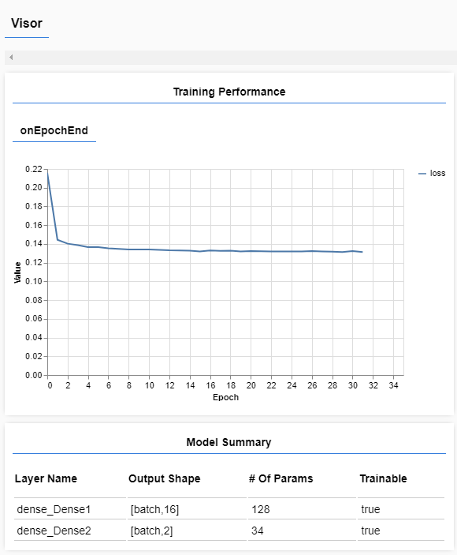

Figure 4.4: Visual feedback for model training using ML5.js

After training, the model will be exported so that we can test it’s validation accuracy. This will determine if the model can be used or not. The model’s exports will include 3 files:

* model_meta.json
* model.json
* model.weights.bin

The models’s data is stored across these three files and will be explained later in detail

We will repeat the model creation process training using:

1. Bottom Half of dataset to train, Top Half of dataset to test
2. Top 75% of dataset to train, Bottom 25% of dataset to test
3. 100% of dataset to train

We will determine the validation accuracy for all models. But for the training session using the Top Half of dataset to train, the full training script now looks like this:

const baseURL = "http://127.0.0.1:8080/";

//Fetch top half of data data to train

axios

  .get(`${baseURL}datasets/new/tophalf`)

  .then((trainResultData) => {

    const trainResult = trainResultData.data.file;

    console.log(trainResult);

    const options = {

      task: "classification",

      debug: true,

    };

    const nn = ml5.neuralNetwork(options);

    trainResult.splice(0, 500).forEach((item) => {

      const inputs = {

        cough: item.cough,

        fever: item.fever,

        sore_throat: item.sore_throat,

        head_ache: item.head_ache,

        shortness_of_breath: item.shortness_of_breath,

        age_60_and_above: item.age_60_and_above === "Yes" ? 1 : 0,

        gender: item.gender === "male" ? 0 : 1,

      };

      const output = {

        corona_result: item.corona_result,

      };

      nn.addData(inputs, output);

    });

    nn.normalizeData();

    const trainingOptions = {

      epochs: 32,

      batchSize: 12,

    };

    nn.train(trainingOptions, () => {

      nn.save();

    });

  })

  .catch((err) => {

    console.error(err);

  });

**4.1.2 TESTING THE NEURAL NETWORK MODEL**

Now that the model has been trained and exported, we can move on to testing the model. As mentioned earlier, we will train and test with three other methods apart from the one performed in 4.1.1:

1. Bottom Half of dataset to train, Top Half of dataset to test
2. Top 75% of dataset to train, Bottom 25% of dataset to test
3. 100% of dataset to train

The model trained with the top half of the data done in 4.1.1 will be tested with the bottom half of the data. The percentage success of the testing data will determine the validation accuracy of the model and whether we can move it to production or not.

We will create another script file for testing the model after it has been trained. We will call this script test.js

The model options for testing still remain the same as training

const options = {

  task: "classification",

  debug: true,

};

We will create separate array variables for percentageSuccess, correct, and wrong:

const percentageSuccesses = [];

var correct = [];

var wrong = [];

We will then initialize the neural network using the options, load the model.json file and finally in the callback we will begin to test the model using thetesting set.

Using Axios, we will fetch the testing set from the backend server and store the set array in testSegment:

axios.get(`${baseURL}datasets/new/bottomhalf`).then((testingResult) => {

const testSegment = testingResult.data.file

})

We will iterate over each record and then get inputs and the required output from each record using the .map() javascript built-in array function

testSegment.map((testRecord) => {

      const input = {

        cough: testRecord.cough,

        fever: testRecord.fever,

        sore_throat: testRecord.sore_throat,

        head_ache: testRecord.head_ache,

        shortness_of_breath: testRecord.shortness_of_breath,

        age_60_and_above: testRecord.age_60_and_above === "Yes" ? 1 : 0,

        gender: testRecord.gender === "male" ? 0 : 1,

      };

      const output = testRecord.corona_result;

Now we will define a classification function called classify() that will make use of the .classify() ML5 function. This function takes in a parameter and then a callback function. The single parameter is the input to be classified. Since we are making a classification for all members of the testSegment array, we will call the function for each record in the array. The callback function has two parameters:

1. Error: This will be returned if an error occurs while making a classification. We can then log this error to the console using console.error() to view the error.
2. testResults: If no error is found, the results of the classification can be obtained from this parameter.

For each classification we make in the callback function, it can either predict successfully or fail. If the result of the test is ‘negative’ and the model predicts ‘negative’, then it is correct and the model accuracy is said to improve. However if the result of the test is ‘negative’ and the model predicts ‘positive’ or vice versa then the model prediction has failed and the accuracy is lowered.

Finally, the percentage success which will also serve as the validation accuracy will be the (number of correct predictions) / total * 100.

The testing script now looks like this:

function classify() {

        nn.classify(input, (error, testResults) => {

          if (error) {

            console.error("Error: ", error);

          } else {

            const mapp = testResults.map((result, index) => {

              console.log(result);

              if (result.label === output) {

                if (result.confidence > 0.5) {

                  //Prediction is correct

                  const obj = {

                    prediction: true,

                    pos: testResults.indexOf(result),

                  };

                  correct.push(obj);

                } else {

                  //Prediction is inaccurate

                  const obj = {

                    prediction: false,

                    pos: testResults.indexOf(result),

                  };

                  wrong.push(obj);

                }

              }

              return {

                length: testResults.length,

                index,

              };

            });

            return Promise.all(mapp).then((e) => {

              const wrongNum = wrong.length;

              const correctNum = correct.length;

              const total = wrongNum + correctNum;

              const percentageSuccess = Math.floor((correctNum / total) * 100);

              percentageSuccesses.push(percentageSuccess);

            });

          }

        });

      }

classify();

Upon testing the model trained with the top half of the dataset with the bottom half, we yielded a **94.5%** model accuracy. The model

## 4.2 CREATING THE FRONTEND INTERFACE

The frontend for the application would be solely built using ReactJS. I began by using Figma the popular design tool to create the User Interface design (UI Design). The designed would be themed with only a few colors:



Figure 4.5: Color palette for frontend interface

The pages available on the web site would be:

1. Home page
2. Authentication page – User login or register
3. Dashboard
4. New test page
5. View previous test page
6. User account page

Below are some the designed pages on Figma from the preliminary design:

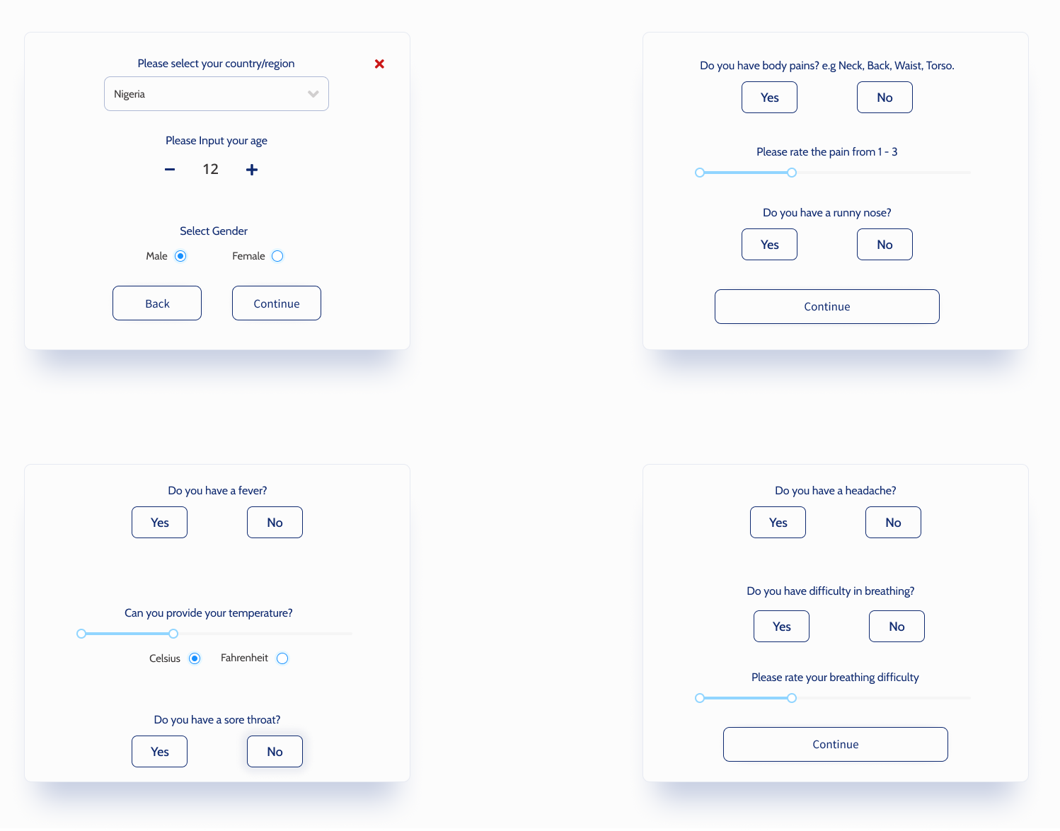

Figure 4.6: Test screen for user

The screen above represents the different segments of the form the user will fill that will give input for the model to make a classification when we move from development into production

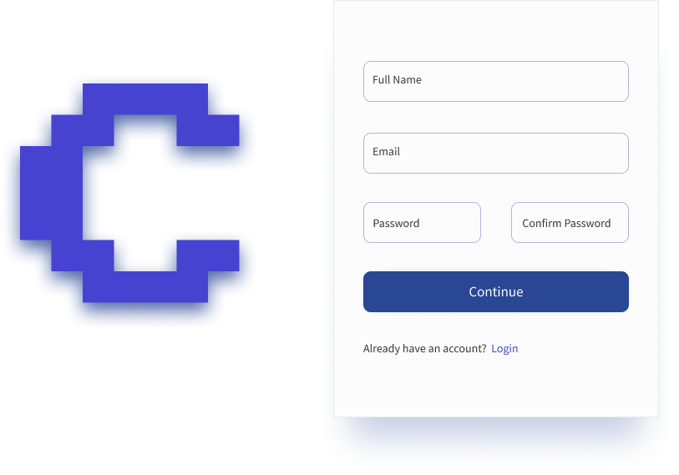

Figure 4.7: Authentication screen for user

The screen above shows the authentication page with the register component. The user will fill this form properly to create an account to use the web application.

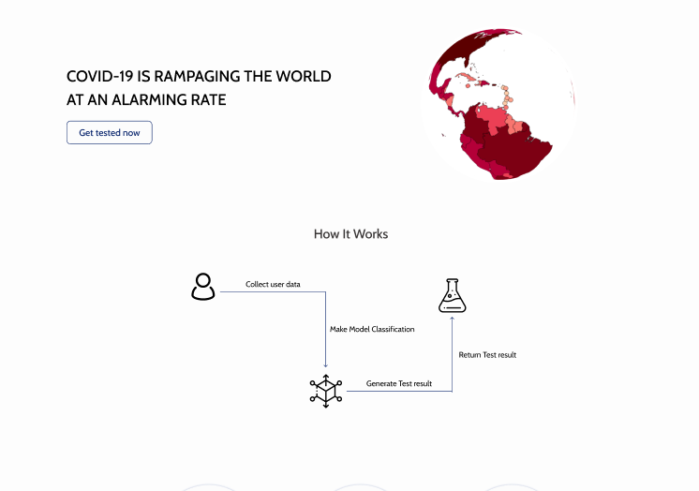

Figure 4.8: Homepage design

Figure 4.8 shows a section of the home page from Figma design. The home page (also sometimes called the index page) will be the default page the user of the site will visit when the launch the web app. It will contain important details about the model including: the dataset used, the model accuracy after testing and testimonials from users who have tested out the model.

After the preliminary design on Figma, the actual User Interface will be converted into code using React as mentioned. React makes it easy to write HTML in Javascript known as JSX. The JSX code can be compiled down to a single index.html file which will be serve as the virtual DOM (Document Object Module). The frontend will be hosted on Github and will deploy on Netlify using CI/CD (Continuous Integration / Continuous Deployment) technique. The following packages will be used in the frontend to make the application more intuitive.

1. Framer motion: This is an animation package by Framer. Framer motion is a React animation library for adding transition effects and other animations. It is free to use and will serve as the animation package.
2. Ant Design: Ant design is a design toolkit that comprises of several components. Components we will make use of include:

* Select
* Radio
* Switch
* Slider
* Modal
* Notification

1. Recharts: Recharts is a Javascript package that is used to plot charts, graphs, and other data visuals. Recharts will be used to show the user the percentage probability of being either positive or negative with the virus.
2. Three.js: Three is one of the most popular 3D libraries available for Javascript. It is used to render 3D shapes, planes and other objects right in the browser. Three will be used on the homepage to show a globe affected by the influence of COVID-19
3. Keen-slider: Keen slider is one of the many available carousel packages for React. It will be used for the slideshow in the homepage for user testimonials
4. Axios: Axios is an alternative to the built in Javascript fetch() API. Axios is used for making API requests in web applications. Axios will be used to exchange data with the NodeJS server running on the backend as well as fetch Covid statistics from RapidAPI
5. Js-cookie: This is a a frontend library for storing and removing cookies in the browser. Cookies will be used to store user sessions while they are logged in.
6. Material UI: MUI (formerly known as Material UI) is a React design library that is open-source. Several components from MUI including: Grid and Container will be used

All packages used will be referenced in a package.json file for building on Netlify servers. A list of the packages in the dependencies from the package.json file:

{

    "@emotion/react": "^11.9.0",

    "@emotion/styled": "^11.8.1",

    "@mui/material": "^5.8.0",

    "@testing-library/jest-dom": "^5.16.4",

    "@testing-library/react": "^13.2.0",

    "@testing-library/user-event": "^13.5.0",

    "antd": "^4.20.5",

    "axios": "^0.27.2",

    "bizcharts": "^4.1.16",

    "framer-motion": "^6.3.3",

    "js-cookie": "^3.0.1",

    "keen-slider": "^6.6.14",

    "ml5": "^0.12.2",

    "react": "^18.1.0",

    "react-dom": "^18.1.0",

    "react-router-dom": "^6.3.0",

    "react-scripts": "5.0.1",

    "react-toast-notifications": "^2.5.1",

    "recharts": "^2.1.9",

    "three": "^0.140.2",

    "web-vitals": "^2.1.4"

  }

## 4.3 CREATING THE BACKEND API

**4.3.1 SETTING UP THE NODE ENVIRONMENT**

The backend of the application will be created using NodeJS and several NodeJS libraries. The backend will perform the following functions:

1. Handle User authentication (Login and Signup)
2. Store new test result in database
3. Retrieve user test results from database
4. Delete test results from database

In development, the backend server will also host dataset files used for training the model. The backend will handle the connection with the MongoDB database running on MongoDB Atlas. MongoDB Atlas is a cloud-based database service that is popular with NodeJS applications but can be used with other languages including: Java, Python, dotNET etc.

I initialize a new NodeJS application by opening up an empty folder and running the node command: npm init. This initializes a new project. I then install the required project dependencies using npm install <dependency> --save. I will list the following dependencies and their functions.

Express: Express is the most popular NodeJS framework. It simplifies the process of defining routes and handling API calls from the frontend. Express replaces the standard HTTP or HTTPS server available on NodeJS with a simple express()method.

Bcrypt: Bcrypt is an encryption and decryption library that is popular for user security. This library will be used to encrypt user passwords before storage in the database.

Body Parser: Body parser is used to obtain form data sent from the frontend to the backend. It enables us to receive data sent from the frontend of the application for proccessing before sending to the database

CORS: Cross-Origin Resource Sharing is a mechanism that prevents unauthorized domains from accessing the backend. A base URL is specified which will have access to the backend. If any other access point attempts to call a route on the backend, CORS will prevent the call from going through.

Mongoose: Mongoose is an ORM (Object Relational Mapping) package available for MongoDB. It allows creating and using models for the database much simpler.

JsonWebToken: JsonWebToken (JWT) is a method of authentication users using tokens that are stored in the users browser and referenced whenever authentication is needed. JWT will be used to keep user logged in for every session.

The dependencies object in the package.json file for the backend server now looks like this:

{

    "bcrypt": "^5.0.1",

    "body-parser": "^1.20.0",

    "cors": "^2.8.5",

    "dotenv": "^16.0.0",

    "express": "^4.17.3",

    "jsonwebtoken": "^8.5.1",

    "mongodb": "^4.5.0",

    "mongoose": "^6.3.1",

    "nodemon": "^2.0.16",

    "randomstring": "^1.2.2"

  }

After installing all the packages required, there is a need to arrange a proper folder structure:

The root directory of the project looks like this:

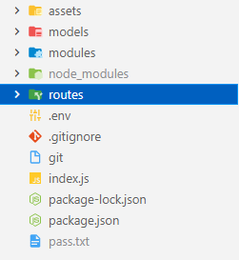

Figure 4.9: Folder structure for NodeJS server

1. Assets: Assets folder will contain the datasets for training the model. This datasets will be sent down via an API call
2. Models: The Models folder will contain all the models and their respective schema that will be used to create data records in the database
3. Modules: The modules folder will contain a single file: main.js It will contain all methods and properties that will be imported by other files across theprogram structure
4. Node_modules: Node_modules is the directory that contains all the libraries and packages installation files used in the application
5. Routes: The routes folder will contain different files that correspond to the respective routes they will handle
6. .env: The .env file will contain environmental variables for the program. This includes port number and MongoDB private url

**4.3.2 AUTHENTICATING USERS INTO THE APPLICATION**

For users to take tests on the website, they must first be logged in to the site. This will enable their test results to be safely stored on the database. It will also allow us to use test results gathered from users for training the model in future. There are two major routes for authentication: "/user/register", "/user/login". These routes will receive form data from the frontend and process it for authentication.

Registering new users

1. Receive form data from the frontend: Name, Email, Password

const { name, email, password } = req.body;

1. Check if user already exists with the email

User.findOne(

    {

      email: email,

    },

1. If user exists, return error:

res.json({

          userExists: true,

          success: false,

        });

1. If user does not exist, use bcrypt to encrypt the password and create a hash that will be stored in the database:

bcrypt.hash(password, salt, (err, hash) => {}

1. Create a new user object using the User schema method
2. const user = new User({

           userID: userID,

           name: name,

          email: email,

              password: hash,

      });

1. Save the new user into the database

user.save();

1. User has been successfully created
2. Use JWT to create a token with the secret key and the user ID (now created in the database)

const token = signJWT(userID);

1. Return the token and a success response to the frontend.

res.json({

           success: true,

           token: token,

      });

Login existing users

1. Get user email and password from form in frontend

const { email, password } = req.body;

1. Check if account with email exists in database

User.findOne({ email: email }, (err, response) => {})

1. User Bcrypt to check is password provided matches password hash stored in database

bcrypt.compare(password, passwordHash, (err, doesPasswordMatch) => {})

1. If password matches create a new token and send positive authentication response with token to frontend.

const token = signJWT(userID);

res.json({

auth: true,

token: token,

});

1. If password does not match send error response to frontend

res.json({

auth: false,

});

In addition to the login and register routes and their respective methods listed above, other routes include:

/isUserAuth: Check if user is authenticated

/test/all: Fetch all user tests

/test/view: View a specific user test

/test/new: Create a new test for the user

/test/modify/: Modify an existing test: either delete or update test

/developer/send: Send a message to the developer

## 4.4 DEPLOYING TO PRODUCTION

After building the entire application, the next step is to move to production. To move to production means to make software accessible to the intended users. We will deploy the backend and frontend on the popular Platform As A Service (PAAS) infrastructures: Heroku and Netlify respectively. The process for deploying both are very similar but require some slightly different configuration.

* + 1. **DEPLOYING THE FRONTEND TO NETLIFY**

1. Move project files to Github: The first step to deploying to Netlify is to move the project files into a new Github repository.
2. Import site from Github: After doing this, the next step is to head to the Netlify dashboard and add new site from Github. This will require authentication into the Github account where out project repository is located.
3. Configure site before initial deploy: To deploy a React website on Netlify, the presence of a _redirects file must be considered. This file informs netlify of our default index.html file which serves as the virtual DOM. The branch to be deployed from Github (in this case the “Main” branch) must also be specified. Finally, it is a safe practice to override project warnings and force compilation to prevent page crashes when the user is on the site.
4. Configure site options: Now that the site has been deployed successfully, site options such as the domain name can be configured: The default sub domain for all Netlify apps is : netlify.app. Once the domain name has been obtained, users can now access the site from anywhere in the world
   * 1. **DEPLOYING THE BACKEND TO HEROKU**

Heroku is a popular PAAS that supports the deployment of many server-side application including: Python, Laravel, Golang and NodeJS. The following steps must be taken to deploy a NodeJS application:

1. Move project files to Github: Similar to Netlify, the first step to deploying to Heroku is to move the project files into a new Github repository.
2. Import repository from Github: After doing this, the next step is to head to the Heroku dashboard and import the repository from Github. This will require authentication into the Github account where out project repository is located.
3. Select branch to Deploy: The next step is to select the branch where the complete project is located, in this case that is the Main branch as well
4. Configure server options: The server environment variables must be configured for the server to start. The presence of a Procfile file must be present on our Heroku server as well. A Procfile tells Heroku the command to start up our project
5. Deploy site: After configuring the server options and implementing a Procfile, the final step is to deploy the site and trigger automatic deploys. Automatic deploys mean the site deploys automatically when changes are made to the Github repository

The final process to our web application is to link both the frontend with the backend. This is done simply by changing the baseURL on the React app to the NodeJS heroku domain and similarly changing the CORS request origin on the NodeJS server to the Netlify domain url. Now the frontend can exchange data with our NodeJS server

# **CHAPTER FIVE**

## 5.1 CONCLUSION

COVID-19 is a global disease that brought the world to a different way of living. This was as a result of the sporadic spread through personal contacts. This makes the need for diagnosis essential and doing so early crucial. Employing an efficient and accurate machine learning technique is essential. Neural network has been realized to be a robust and fault tolerant artificial intelligence model for prediction and diagnosis. In this research, we developed a diagnosis system for COVID-19 using neural network. Although the dataset used is linear in nature, it yielded a high accuracy of 96%. The neural network provide support for medical practitioners working on COVID-19 patients to help triage them faster for actual Reverse Transcription Polymerase Chain Reaction (RT-PCR) testing. This will reduce the strain of running numerous tests daily. The source code for the model will be made available freely online for individuals to tweak and understand. Scientists will be able to study COVID-19 related symptoms better and understand how each symptom affects patients’ chances of being infected with the coronavirus. The challenge to accessing global data makes it essential to make COVID-19 related datasets available to data scientists across world. These datasets should be made public for anyone to access. Hospitals and other medical centers should adapt Artificial Intelligence in aiding the fight against COVID-19. We look forward to conducting a validation and evaluation of this model in future

## 5.2 CONTRIBUTION TO KNOWLEDGE

Although the dataset used is linear in nature, it yielded a high accuracy of 96%. The neural network will assist medical practicioners working on COVID-19 patients to help triage them faster for actual Reverse Transcription Polymerase Chain Reaction (RT-PCR) testing. This will reduce the strain of running numerous tests daily.

The source code for the model will be made available freely online for individuals to tweak and understand. Scientists will be able to study COVID-19 related symptoms better and understand how each symptom affects a patients chances of being infected with the coronavirus

## 5.3 RECOMMENDATION

The strong recommendation after this research work is for the availability of more COVID-19 related datasets to be made available to data scientists to work with all over the world. The governments around the world should have a nationwide record of how the coronavirus, it’s symptoms and it’s effects are affecting their people. These datasets should be made public for anyone to access. Hospitals and other medica centers should adapt Artificial Intelligence in aiding the fight against COVID-19. Individuals all around the world should abide by COVID-19 regulations put in place by their governments and advised by the WHO.

# **REFERENCES**

Abbasi, W. A., Abbas, S. A., Andleeb, S., ul Islam, G., Ajaz, S. A., Arshad, K., Khalil, S., Anjam, A., Ilyas, K., Saleem, M., Chughtai, J., & Abbas, A. (2021). COVIDC: An expert system to diagnose COVID-19 and predict its severity using chest CT scans: Application in radiology. *Informatics in Medicine Unlocked*, *23*, 100540. https://doi.org/10.1016/j.imu.2021.100540

Abdel-Basst, M., Mohamed, R., & Elhoseny, M. (2020). A model for the effective COVID-19 identification in uncertainty environment using primary symptoms and CT scans. *Health Informatics Journal*, *26*(4), 3088–3105. https://doi.org/10.1177/1460458220952918

Afzal, A. (2020). Molecular diagnostic technologies for COVID-19: Limitations and challenges. *Journal of Advanced Research*, *26*, 149–159. https://doi.org/10.1016/j.jare.2020.08.002

Albawi, S., Mohammed, T. A. M., & Alzawi, S. (2017). Layers of a Convolutional Neural Network. *Ieee*, 16.

Alsunaidi, S. J., Almuhaideb, A. M., Ibrahim, N. M., Shaikh, F. S., Alqudaihi, K. S., Alhaidari, F. A., Khan, I. U., Aslam, N., & Alshahrani, M. S. (2021). Applications of big data analytics to control covid‐19 pandemic. *Sensors*, *21*(7). https://doi.org/10.3390/s21072282

Ananthi, S., & Hariganesh, S. (2015). A comprehensive study on cloud computing. *ICIIECS 2015 - 2015 IEEE International Conference on Innovations in Information, Embedded and Communication Systems*. https://doi.org/10.1109/ICIIECS.2015.7193151

Barnes, J. (2015). Azure Machine Learning Microsoft Azure Essentials. In *Microsoft Press*. http://www.microsoft.com

Brown, C., Chauhan, J., Grammenos, A., Han, J., Hasthanasombat, A., Spathis, D., Xia, T., Cicuta, P., & Mascolo, C. (2020). Exploring Automatic Diagnosis of COVID-19 from Crowdsourced Respiratory Sound Data. *Proceedings of the ACM SIGKDD International Conference on Knowledge Discovery and Data Mining*, 3474–3484. https://doi.org/10.1145/3394486.3412865

Carretero, J., & Blas, J. G. (2014). Introduction to cloud computing: platforms and solutions. *Cluster Computing*, *17*(4), 1225–1229. https://doi.org/10.1007/s10586-014-0352-5

Fauci, A. S., Lane, H. C., & Redfield, R. R. (2020). Covid-19 — Navigating the Uncharted. *New England Journal of Medicine*, *382*(13), 1268–1269. https://doi.org/10.1056/nejme2002387

Fegert, J. M., Vitiello, B., Plener, P. L., & Clemens, V. (2020). Challenges and burden of the Coronavirus 2019 (COVID-19) pandemic for child and adolescent mental health: A narrative review to highlight clinical and research needs in the acute phase and the long return to normality. *Child and Adolescent Psychiatry and Mental Health*, *14*(1), 1–11. https://doi.org/10.1186/s13034-020-00329-3

Giri, A. K., & Rana, D. R. (2020). Charting the challenges behind the testing of COVID-19 in developing countries: Nepal as a case study. *Biosafety and Health*, *2*(2), 53–56. https://doi.org/10.1016/j.bsheal.2020.05.002

He, F., Deng, Y., & Li, W. (2020). Coronavirus disease 2019: What we know? *Journal of Medical Virology*, *92*(7), 719–725. https://doi.org/10.1002/jmv.25766

Holstein, B. (2020). Coronavirus 101. *Journal for Nurse Practitioners*, *16*(6), 416–419. https://doi.org/10.1016/j.nurpra.2020.03.021

Journal, E., & Ejt, T. (2017). *Vol 7, Number 2, 2017 European Journal of Technique EJT*. *7*(2), 207–218.

Lan, F. Y., Filler, R., Mathew, S., Buley, J., Iliaki, E., Bruno-Murtha, L. A., Osgood, R., Christophi, C. A., Fernandez-Montero, A., & Kales, S. N. (2020). COVID-19 symptoms predictive of healthcare workers’ SARS-CoV-2 PCR results. *PLoS ONE*, *15*(6), 1–12. https://doi.org/10.1371/journal.pone.0235460

Lecun, Y., Bengio, Y., & Hinton, G. (2015). Deep learning. *Nature*, *521*(7553), 436–444. https://doi.org/10.1038/nature14539

Lella, K. K., & PJA, A. (2021). A literature review on COVID-19 disease diagnosis from respiratory sound data. *AIMS Bioengineering*, *8*(2), 140–153. https://doi.org/10.3934/bioeng.2021013

McAleer, M. (2020). Prevention Is Better Than the Cure: Risk Management of COVID-19. *Journal of Risk and Financial Management*, *13*(3), 46. https://doi.org/10.3390/jrfm13030046

Mei, X., Lee, H. C., Diao, K. yue, Huang, M., Lin, B., Liu, C., Xie, Z., Ma, Y., Robson, P. M., Chung, M., Bernheim, A., Mani, V., Calcagno, C., Li, K., Li, S., Shan, H., Lv, J., Zhao, T., Xia, J., … Yang, Y. (2020). Artificial intelligence–enabled rapid diagnosis of patients with COVID-19. *Nature Medicine*, *26*(8), 1224–1228. https://doi.org/10.1038/s41591-020-0931-3

Naqa, I. El, & Murphy, M. J. (2015). Machine Learning in Radiation Oncology. *Machine Learning in Radiation Oncology*, 3–11. https://doi.org/10.1007/978-3-319-18305-3

Neelam, M. (2022). *Neelam MahaLakshmi (2021) Aspects of Artificial Intelligence In Karthikeyan.J, Su-Hie Ting and Yu-Jin Ng (eds), “Learning Outcomes of Classroom Research” p:250-256, L’ Ordine Nuovo...* (Issue January).

Prince, D. J. (2011). Introduction to cloud computing. *Journal of Electronic Resources in Medical Libraries*, *8*(4), 449–458. https://doi.org/10.1080/15424065.2011.626360

Quiroz-Juárez, M. A., Torres-Gómez, A., Hoyo-Ulloa, I., de León-Montiel, R. D. J., & U’Ren, A. B. (2021). Identification of high-risk COVID-19 patients using machine learning. *PLoS ONE*, *16*(9 September), 1–21. https://doi.org/10.1371/journal.pone.0257234

Saif, L. J., Wang, Q., Vlasova, A. N., Jung, K., & Xiao, S. (2019). *Coronaviruses*. *M*, 488–523.

Soh, J., Copeland, M., Puca, A., & Harris, M. (2020). Microsoft Azure and Cloud Computing. *Microsoft Azure*, *Im*, 3–20. https://doi.org/10.1007/978-1-4842-5958-0_1

Stojanovic, R., Skraba, A., & Lutovac, B. (2020). A Headset Like Wearable Device to Track COVID-19 Symptoms. *2020 9th Mediterranean Conference on Embedded Computing, MECO 2020*, 8–11. https://doi.org/10.1109/MECO49872.2020.9134211

Velavan, T. P., & Meyer, C. G. (2020). The COVID-19 epidemic. *Tropical Medicine and International Health*, *25*(3), 278–280. https://doi.org/10.1111/tmi.13383

Wu, Z., & McGoogan, J. M. (2020). Characteristics of and Important Lessons From the Coronavirus Disease 2019 (COVID-19) Outbreak in China. *Jama*, *323*(13), 1239. https://doi.org/10.1001/jama.2020.2648

Zoabi, Y., Deri-Rozov, S., & Shomron, N. (2021). Machine learning-based prediction of COVID-19 diagnosis based on symptoms. *Npj Digital Medicine*, *4*(1), 1–5. https://doi.org/10.1038/s41746-020-00372-6